OUTPUT  
  
1. The Driver is writing at time 5   
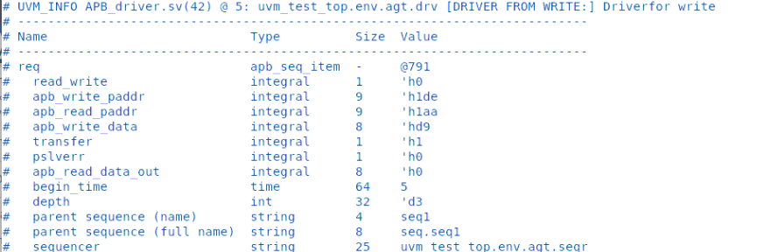

2. Write operation completed at 25  
  
3.Read operations starting at 25

4. Data Read Succesfully  
